Scan Object Tutorial

For this script to work you would need to have finished doing the object to scan script as that script will be used in the scan object script. Heres a screenshot of the script below

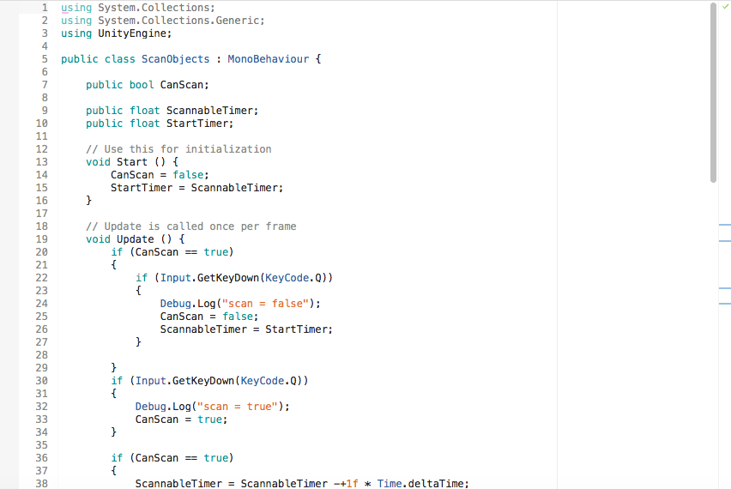

You create two public floats scannable timer and start timer. Scannable timer will be how long an object will be scanned for when the player presses the scan button. You add coding for when you can scan an object and you can decide what key you want to assign for the scan mechanic in the screenshot the key is Q. So you add the getkeydown code as shown above and you add whatever key you want used.

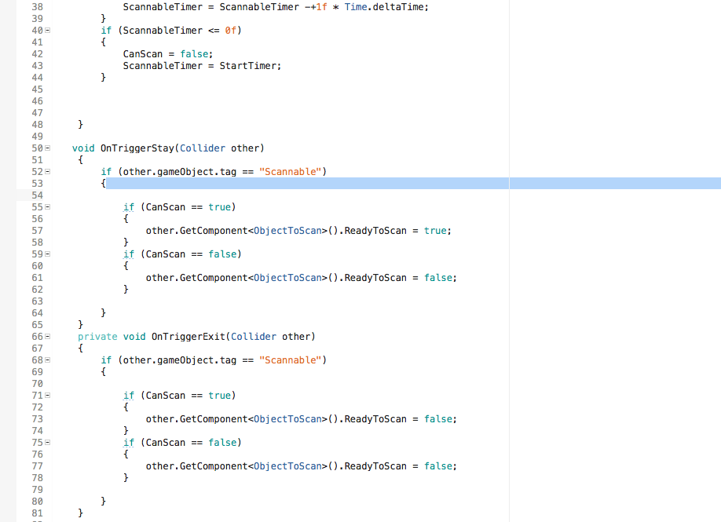

In the screenshot above you add a code for a gameobject tag and call it whatever you want but in the screenshot it is called scannable. So an object with this tag would be able to be scanned and change colour. Therefore you will need to create a tag you do this in the inspector and you should see tag at the top and click on the tab and add a tag.

The code between 71 and 77 in the screenshot requires the object to scan script without the script the object in the environment won't be able to change colour to indicate its being scanned